**DAILY ONLINE ACTIVITIES SUMMARY**

|  |  |  |  |  |  |  |  |
| --- | --- | --- | --- | --- | --- | --- | --- |
| **Date:** | **16/06/2020** | | | | **Name:** | **Sheetal** | |
| **Sem & Sec** | **8 B** | | | | **USN:** | **4AL16CS091** | |
| **Online Test Summary** | | | | | | | |
| **Subject** | | **BDA** | | | | | |
| **Max. Marks** | | **30** | | **Score** | | **24** | |
| **Certification Course Summary(Internship)** | | | | | | | |
| **Task** | **Dynamic BI Automation-Extracting and loading dataset into BI tool using python scripting** | | | | | | |
| **Company** | | | **Gain-Insights** | **Duration** | | | **8 hr** |
| **Coding Challenges** | | | | | | | |
| **Problem Statement:**  **1) Given a string input Count all lower case, upper case, digits, and special symbols** | | | | | | | |
| **Status:completed** | | | | | | | |
| **Uploaded the report in Github** | | | | **Yes** | | | |
| **If yes Repository name** | | | | [alvas-education-foundation](https://github.com/alvas-education-foundation)/ **[sheetal-shettigar](https://github.com/alvas-education-foundation/sheetal-shettigar)** | | | |
| **Uploaded the report in slack** | | | | **Yes** | | | |

ONLINE TEST

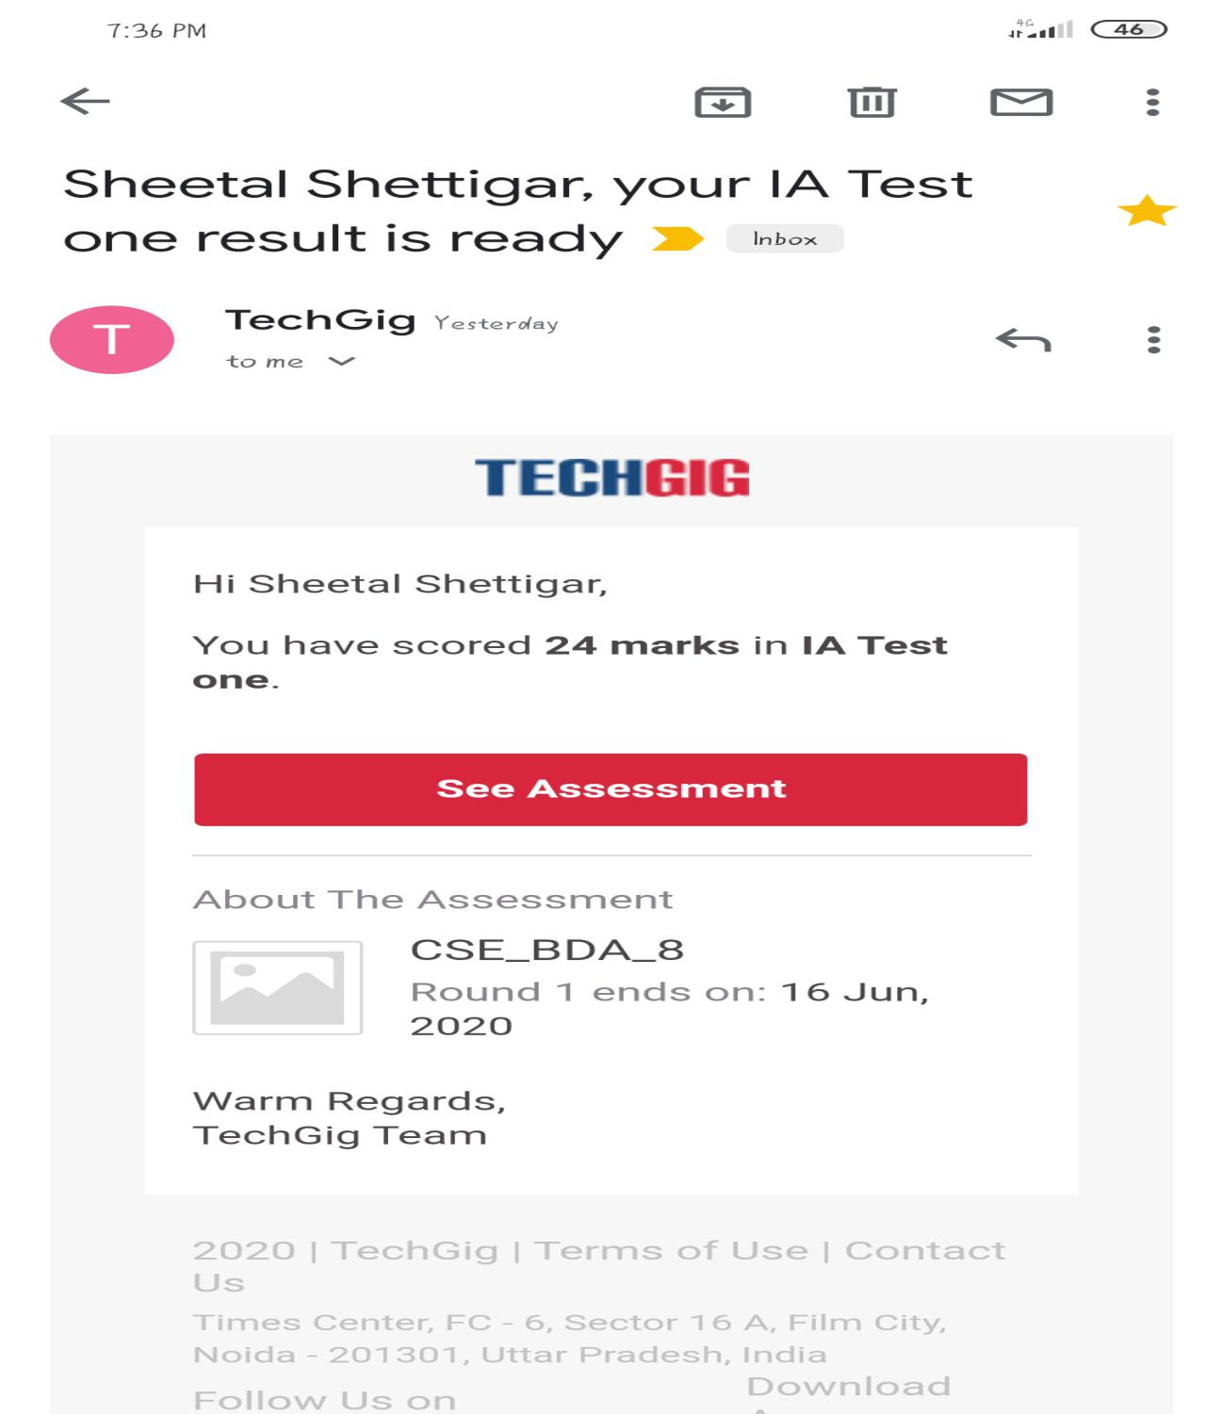

CODING CHALLENGE:

PROGRAM 1 :

def findDigitsCharsSymbols(inputString):

words = inputString.split()

charCount = 0

digitCount = 0

symbolCount = 0

for char in inputString:

if char.islower() or char.isupper():

charCount+=1

elif char.isnumeric():

digitCount+=1

else:

symbolCount+=1

print("Chars = ", charCount, "Digits = ", digitCount, "Symbol = ", symbolCount)

inputString = "P@#yn2"

print("total counts of chars, digits,and symbols")

print(findDigitsCharsSymbols(inputString))